There’s a War on Minimum Wage, Here’s How it Impacts Us All

Queens University

Myna Watford

COM 638 – Global Communication

According to the Business Insider, the average price of a home in 2019 is nearly $226,800. The cost of buying a home has increased significantly since the 1960’s, when the median price of a home was $11,900, or $96,681, when adjusted for inflation, according to a Student Loan Hero Report (Hoffower & Brandt, 2019). Hourly minimum wage during the 1960’s was $1.29, and considering the cost of living was substantially lower, than the monetary amount seemed to balance out with the household needs (US. Department of Labor & Wage, 2009). Especially considering that the family structure typically consisted of a working Father, a homemaker Mother, and children who had no tasks other than to enjoy their childhood respectfully.
Nonetheless, times have significantly changed since then. The family structure is now comprised of both traditional and non-traditional groups, and the overall cost of living has surged so drastically that it often takes more than one breadwinner to sustain the household. Now, it is more common than not, that a household consists of more than one working adult, along with teenage child(ren) at times. Ironically, those combined incomes can’t always support the financial burdens of a household. When Congress passed the Fair Labor Standards Act in 1938, it represented a major shift in the labor policy. For the first time, the federal government set a minimum wage and established the principle that people – or at least those covered by the law – are entitled to a certain amount of pay for their work. One reason that the federal minimum wage provokes continuing controversy is that it doesn’t automatically adjust to the rising cost of living. “This means it is completely dependent upon political negotiations, and its level depended upon which forces had power, “ explains Stephanie Luce, the chairperson and a professor in the School of Labor and Urban Studies at City University of New York. Since the federal minimum wage was set in 1938, it has been raised 22 times by 12 different presidents (Kiger, 2019).
When it comes to setting employee salaries or wages, you can’t pay any amount you want. You must follow minimum wage law. The minimum wage is the lowest amount you can pay an employee per hour of work. You can pay more than the minimum wage, but you cannot pay less than the minimum wage (Kappel, 2012). Currently, one hour of work at minimum wage ($7.25) can barely afford two 2 gallons of regular milk. One of the issues that seems to be prevalent and of interest to me, is the inability to work towards obtaining a “livable or sustainable” minimum wage. For the past 10yrs, the Federal minimum wage has been $7.25, up just .70 cents from $6.55. Before taxes, if an individual working at the minimum wage rate would gross around $1160 per month (40 hrs. per week); however, in the city of Charlotte alone, you wouldn’t even be able to afford a decent apartment in a safe neighborhood at that rate. Nonetheless, there are some small businesses who argue that they could not afford to retain employees if the minimum wage increases.
The United States has one of the lowest minimum wages of any advanced democracy in the world. Those low wages are a factor in everything from rising income inequality to high child poverty rates to high rates of public spending on assistance programs for low-income families (Ingraham, C. 2018). So, what do American’s do when there is a substantial need to increase their earnings based on the cost of living, but the income gap between the wealthy and poor seems to be widening? This strategic communication plan looks at how a proposed solution to increase the federal minimum wage, may solve some problems locally, but potentially create others on a more global scale.
Literature Review

Recently the CEO of Bank of America, made an announcement that the company was increasing their minimum wage to $20 per hour, up from $17 per hour just a few short years ago. The bank’s move comes as the minimum wage has become a hot-button issue in Washington. In July, the House passed a bill to raise the federal minimum wage to $15 per hour (Imbert, 2019). However, that move by the House has come with plenty of resistance.
Naturally, that inquisitiveness of that resistance by some, led to the search for additional articles pertaining to the debate on minimum wage. Puzzled; it caused me to question how a thriving economy, could continue to stagnate or stifle the income of the less fortunate. One central argument advised that increasing the minimum wage would force businesses to lay off employees and raise unemployment levels. The Congressional Budget Office projected that a minimum wage increase from $7.25 to $10.10 would result in a loss of 500,000 jobs. In a survey of 1,213 businesses and human resources professionals, 38% of employers who currently pay minimum wage said they would lay off some employees if the minimum wage was raised to $10.10; while 54% said they would decrease hiring levels. San Francisco’s Office of Economic Analysis said that an increase to $15 would reduce the city’s employment by about “15,270 private sector jobs’ (ProCon.Org, 2019).
Despite a major corporation like Bank of America being able to meet the supply and demand of a higher hourly salary for its workers, there are other small businesses that likely may not be able to afford the hike. Large businesses only employ about 38% percent of the private sector workforce while small businesses employ 53% percent of the workforce. In fact, over 99 percent of employing organizations are small businesses and more than 95% percent of these businesses have fewer than 10 employees. The reality is that most Americans are employed by a very small business that has little in common with the tiny sliver of the business demographic represented by Corporate America (Arsian, 2011).
The percent of small business owners in the private sector, is significant in the fact that it identifies just how many Americans rely on a smaller corporation to support and feed their families. If these businesses fail, then ultimately that means that the households that they support fail also. This led to an additional article highlighting the damage that a forced increase would do on a smaller corporation. A minimum wage increase would hurt businesses and force companies to close. 60% of small-business owners say that raising the minimum wage will “hurt” most small business owners,” according to a 2013 Gallup poll. Jamie Richardson, MBA, Vice President of fast food chain White Castle, said that the company would be forced to close almost half its stores and let go thousands of workers if the federal minimum wage were raised to $15 (ProCon.Org, 2019). America was built on the backs of small businesses; therefore, any damage done to them could cause irreversible damage to America as a whole.
There are also those who believe that a change or increase would not be beneficial to those in poverty. The 2012 Wilson review noted: “Since 1995, eight studies have examined the income and poverty effects of minimum wage increases, and all but one has found that past minimum wage hikes had no effect on poverty (Wilson, 2012). A study from the Federal Reserve Bank of Cleveland found that although low-income workers see wage increases when the minimum wage is raised, “their hours and employment decline, and the combined effect of those changes is a decline in earned income…minimum wages increase the proportion of families that are poor or near poor.” Thomas Grennes, MA, Professor Emeritus at North Carolina State University, and Andris Strazds, MSc, Lecturer at the Stockholm School of Economics in Riga (Latvia), stated: “The net effect of higher wages would be unfavorable for impoverished households, even if there are no job losses. To the extent that some poor households also lose jobs, their net losses would be greater” (Greenes & Strazds, 2015). Yet, senator, and Presidential hopeful, Bernie Sanders has found the exact opposite to be true. According to a new study prepared by the Government Accountability office for Sen. Bernie Sanders (I-VT), the federal minimum wage is leaving millions of families in poverty. While 20 percent of working families earning the $7.25 minimum wage or below live in poverty, 13 percent of families with a worker earning up to $12 per hour live in poverty and 5 percent of families with a worker earning up to $16 per hour live in poverty. Sanders has called for Legislation to increase the federal minimum wage to a living wage of $15 per hour. “As this new report shows, $7.25 minimum wage is a starvation wage that is not enough to keep working families out of poverty”. The GAO (Government Accountability Office) found that higher wages were associated with lower poverty rates. Low-wage workers – those earning $16 per hour or less- comprise about 40 percent of the U.S. workforce age 25 – 64. Millions of these working families and their children are living in poverty as a result of low wages. In 2016, nearly half (48 percent) of single-parent families with a minimum wage worker were living in poverty. In families where the single parent was earning between $12 to $16 per hour, the poverty rates dropped from 48 percent to 17 percent (Bernie Sanders, 2017).

Theoretical Framework

So, the question then becomes, how do we satisfy the needs of two separate groups, both the employer and the employee, without hurting either party. Based on inflation, there is clearly a need to raise income levels, but can it be done in a way that doesn’t compromise small business? Research seems to swing the pendulum in both directions, so the most conclusive theory surrounds impression management. Erving Goffman’s sociological work is centered around theories of social interaction derived from his empirical work in different settings. He analyzes the relationship between interpersonal meanings and social structure, paying attention to both the symbolic value of what is said and done and the more abstract forms of social life (Ihlen & Fredriksson, 2018, p. 253). Considering this, how the messaging of minimum wage is conveyed or framed, determines how receivers perceive the information. We tend to perceive events in terms of primary frameworks, and the type of framework we employ provides a way of describing the event to which it is applied. Expectations facilitate our comprehension and interpretation of objects and events, while also influencing our perceptions (p. 256).
Frames, furthermore, organizes more than meaning; they also organize involvement (1974). During an activity, participants will ordinarily not only obtain a sense of what is going on but will also (to some degree) become spontaneously engrossed, caught up, involved or committed (p. 257). Ironically, framing is essentially the doorway to footing for a participant. Footing is a concept which concerns participants’ stance or posture in interaction, in Goffman’s own words: “Participant’s alignment, or set, or stance, or posture, or projected self is somehow at issue” (Goffman, 1981, p. 128). This implies that footing includes both verbal and non-verbal signals representing participants attitudes towards the issue of communication (p. 257).
People’s impression or perception of minimum wage is a direct correlation to how that information was conveyed to them early on. If the social media sites and programming that they follow, drive the content of information to merely one direction, then their perspective becomes laser focus in either agreement or disagreement with the change. In order to understand the entire complex issue, all facts must be presented, along with viable solutions if true change is the ultimate end goal. Otherwise, you have two opposing sides, stonewalled, and leaving a helpless middleman (or woman) in the center of it all.
This paper looks to understand the concerns of a hike in minimum wage, and what the impact would be for both sides. The following questions will be addressed:

1: What are some of the reoccurring concerns or themes that derive from users found on social media?
2. How are those issues relevant to a broader issue, and what can be done to remediate the matter?

Methodology
In order to determine the holistic impact that minimum wage has, a decision was made to explore the impact on a micro-level first and foremost. The process of doing this, consisted of examining several social media pages that are dedicated to the fight for increased minimum wage, YouTube videos that support or oppose it, and commentary on these sites that analyzes the thoughts of those who desire to make more, but are faced with challenges. The various channels and responses will confirm that there is no one solution fix all to this problem. What may benefit some, will undoubtedly hurt others, yet doing nothing is undoubtedly not an option.
Although the fight for minimum wage is not a new one, the momentum for change seems to flatline according to whether or not it is an agenda item for political candidates. During election years, the concern for the poor and mistreated, seems to reach an all-time high, with popular talk centered around raises in the federal minimum wage, affordable health care, and big businesses paying their fair share. Unfortunately, this practice has come to be more of a routine than an efficient movement for actual change.
Therefore, to capture the true essence of those impacted, I took a look at the commentary shared on social media sites (Facebook, and Instagram) from groups such as Raising the Minimum Wage and National Living and Minimum Wage within the past 6 months or less (May 2019 – Nov 2019). This information was obtained via all the Facebook posts from the specified time timeframe, and a small sample being taken from each of them. The selected sample was determined based on what comments had the most likes, or algorithms Facebook used to isolate the most relevant comments under each posting. For Instagram, I simply utilized the hashtags #minimumwage and #increaseminimumwage with the same 6-month window, since the content is not updated on a consistent basis. This allowed for a longer incubation period based on content observation.

Open/Initial Coding
The initial part of the grounded theory process required open coding. Your research adventure begins with finding and generating data. Gathering rich data will give you solid material for building a significant analysis. Grounded theories may be built with diverse kinds of data – fieldnotes, interviews, and information from records and reports. The kind of data the researcher pursues depends on the topic and access (Charmaz, 2014, p. 23).
Coding is the pivotal link between collecting data and developing an emergent theory to explain this data. Through coding, you define what is happening in the data and begin to grapple with what it means (p. 113). The goal here was to obtain data from each of the specified resources and determine if there is a consistent theme among users across social media sites as it pertains to minimum wage. This section created a collage of data that had to be sorted, but still remain open enough to develop an equally large database to pull resources from. Grounded theory coding is a powerful tool that can enable you to define what constitutes the data and to make implicit views, actions, and processes more visible (p. 113).
In this phase, I wanted to capture the responses of participants in their most authentic form, and not be swayed by any preconceived notions or personal biases towards the fight for an increased hourly minimum wage. Becoming aware of your preconceptions as you engage in the iterative process of coding, memo-writing, and collecting data enriches your analysis (p. 156). During initial coding, the goal is to remain open to all possible theoretical directions indicated in your readings of the data (pg. 114). Therefore, data was absorbed and then moved to sorting or categorizing in the next phase.
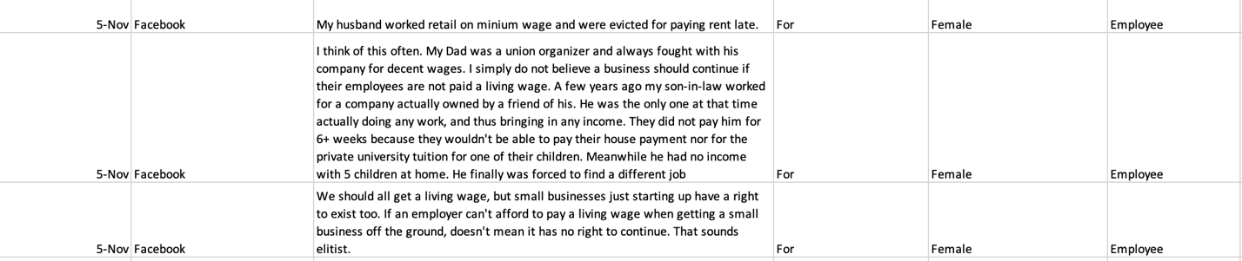
*Example of Open Data, utilized to support Research Question*

Focused Coding
Focused coding directs our analysis early in the research process and helps us to evaluate the directions we take without embarking on a path of no return. This process entails using the most significant and or frequent earlier codes to sift through and analyze large amounts of data. Focused coding required decisions about which initial codes make the most analytic sense to categorize your data incisively and completely (pg. 138).
Through this step, I was able to take a close look at the data that had been obtained through open coding and start grouping the information into recurring themes or categories. The data was no longer simply a pool of endless information, but resourceful content that aided in identifying patterns of the responders…what they thought, and why they personally felt that way. I started to recognize that themes were forming and the trigger words of inflation, small businesses, wages, and etc. slowly but surely developing in the data. So much so, that they would be entirely hard to ignore, as they rose to the surface no matter where the data was obtained from.
Axial Coding
During initial coding you fracture the data into separate pieces and construct distinct codes. Axial coding is Strauss and Corbin’s (1998) strategy for bringing data back together again in a coherent whole. According to Strauss and Corbin, axial coding answers questions such as ‘when, where, why, who, how, and with what consequences’ (p. 147).
Once categories were formed based on the present theme, similarities in the responder’s content started emerging. One reoccurrence I began to document was surrounded ‘who’ was commenting on these social media sites, such as whether or not they were an employee or possibly an employer, as that would potentially alter their perspective. A mother addressing the struggles of living off a minimum wage salary with two kids, would vary greatly from the boss who employs her, and others like her. Both visions and perspectives are ultimately skewed by their own circumstances. Those who were living off of minimum wage tended to have a more passionate response, as they were able to directly reiterate some of the problematic factors of this issue firsthand. The subsequent categories, subcategories, and links reflect how I made sense of the data (p. 148).

Exploration of Saturation
At some point it becomes a realization that data is no longer producing new content variables or outcomes, merely the same themes, just explained in various ways. Categories are ‘saturated’ when gathering fresh data no longer sparks new theoretical insights, nor reveals new properties of these core theoretical categories (p. 213). Theoretical saturation is what grounded theorist aim for- or should aim for, according to the canons . In the sampling strategy, the researcher does not seek ‘generalizability’ or ‘representativeness’ and therefore focuses less on sample size and more on sampling adequacy. Sample size is important only as it relates to judging the extent to which issues of saturation have been carefully considered (p. 214).
At this point, the content surrounding research on minimum wage no longer needed to be collected or sorted, but more so, analyzed to determine if a new theory or hypothesis could be formed. Enough data had been collected from various tools, that would provide a decent pooling sample of what the concerns where. Now it was time to put that plethora of information into use.

Results
Through the course of research surrounding the minimum wage war, a few consistent themes seemed to emerge habitually. The resources utilized to conduct this research came from social media sites such as Facebook and Instagram. Earlier memo writing and open coding allowed for consistent or reoccurring themes found within the comments to be grouped into categories and subcategories based on their likeness to the topic at hand. The central themes that formed were as follows…livable wages, age specifics, small businesses, inflation, and location. Naturally, these topics produced some other topic outliers surrounding skillset, automation, and gender discrimination; however, the meat and potatoes of the research, stemmed from the central themes highlighted above and described below. In order to establish the significance of each theme, direct audience feedback has been incorporated as a measuring tool to reach a well-developed hypothesis on the overall topic.

Livable Wages Matter

One of the central themes that appeared to lead the pack early on, was the need for individuals to have and obtain “livable wages”, as a means of increasing the minimum wage. This argument was mainly fueled by the fact that the cost of living has drastically risen, yet wages have essentially become stagnant in the growth cycle. Undoubtedly, this has created a disparity between the ‘have and have nots’, as some consumers must find alternative methods to make ends meet and keep a roof over their head in the process.
According to one Facebook user, in the Raise the Minimum Wage group, “$15 per hour is not extravagant or unreasonable. It might keep a single person afloat. …in a studio apartment, no car payment, no kids, and provide basic necessities. Reduce the amount of state assistance”. The point of the user in this example, highlights how even at an increased minimum wage rate of $15 per hour, it would still merely graze the surface of being a livable wage; employees would still need to rely on additional resources to meet monthly household expenses without anything extra. Kids, car(s), and other typical life expenses would ultimately alter the ability for a person to live comfortably, as even an increased wage would not suffice based on inflation.
Another Facebook user stated the following (Raise the Minimum Wage)… “$15 an hour where I live and still not enough. The rent goes up every 5 months”. This argument reinforces two separate themes; not only are the wages not enough to maintain a decent livelihood, but an increase of wages may also result in an increase in cost elsewhere.
In the United States, the income gap between the rich and everyone else has been growing markedly, by every major statistical measure, for more than 30 years. Income includes the revenue streams from wages, salaries, interest on savings account, dividends from shares of stock, rent, and profit from selling something for more than you paid for it. Unlike wealth statistics, income figures do not include the value of homes, stock, or other possessions. Income inequality refers to the extent to which income is distributed in an uneven manner among the population. Income disparities have become so pronounced that America’s top 10 percent now average more than nine times as much income as the bottom 90 percent. Americans in the top 1 percent tower stunningly higher. They average 39 times more income than the bottom 90 percent. Over the past five decades the top 1 percent of American earners have nearly doubled their share of national income. Meanwhile the official poverty rate for all U.S. families has merely inched up and down. The official poverty rate understates the number of people in the world’s richest country who have trouble making ends meet. An estimated 43.5 percent of the total U.S. population (140 million people) are either poor or low-income (Inequality org, 2019).
According to Ben Zipperer, an economist at the Economic Policy Institute (EPI) in Washington, D.C., every working person deserves a good job with fair pay, affordable health care, and retirement security. To achieve this goal, EPI conducts research and analysis on the economic status of working America. His testimony establishes the following…(1). A national $15 wage by 2024 is an important corrective to ensure that low-wage workers share the benefits of economic growth. (2) The bulk of recent economic research on the minimum wage, as well as the best scholarship, establishes that prior increases have little to no negative consequences and instead have meaningfully raised the pay of the low-wage workforce. (3) Minimum wage workers, and low-wage workers, generally, are mostly adults and are also disproportionately women and people of color. (4). Workers in every region of the country will soon need $15 per hour to maintain a modest adequate standard of living (Zipperer, 2019).

Cost Goes Up

As a result of this, one of the leading counter arguments against raising the minimum wage, points out that if wages increase than so will other goods and services. For most, this would appear to wash away any form of getting ahead financially since it creates a cyclical for most consumers. An increase in minimum wage is ultimately only effective if there is a greater margin between wages and cost of living.
According to a Californian (Facebook – Raise the Minimum Wage), “California has proved that raising the minimum wage has helped nothing. Greedy a** corporations and property managements just raise the cost of everything to match, with the mindset that if you make more you can pay more…By raising the cost of food, fuel, rent, power, and utilities, even the internet prices go up with minimum wage goes up. Maybe look to the real problem and regulate some rental management regulations and unmanageable unrealistic taxes”.
As an employee, if my wages don’t provide a vehicle for me to live a better life (not extravagant), because the increase is offset by inflation, then it waters down my drive or motivation for change. You ultimately see no end to the revolving door, and the economy has undeniably made you the hamster on the Ferris wheel. Under an Instagram post (#IncreaseTheMinimumWage) that highlighted Amazon’s choice to raise their minimum hourly wage to $15 an hour for its US workers, one user wrote “Looks like milk is going to get more expensive soon”. In the same post, a response to that commenter, argued, “If every worker in the United States was given $15 an hour, an CEOs kept the same wages, the dollar menu at McDonalds would just become $1.17 menu. That’s it. So yeah, 3 cents on milk is an exaggeration, but the only reason people aren’t earning living wages is because of the wealth gap between employees and those at the top”. This goes back to framing, and how people connect with the information delivered on a more personal level.
To support the growing inflation concern, CNN shadowed a 22-yr. old single mother by the name of Safiyyah Cotton who was a current employee of McDonalds and only bringing home $230-$240 every 2 weeks, which averages $6,240 annually. Cotton spoke of the hardship of not being able to always reach the hours needed to make ends meet, and relying on government assistance for her housing, food (SNAP), Medicaid, and daycare. One of the most transparent statements made by Cotton highlighted the cyclical of the poverty system funneled by minimum wage. “If I wasn’t getting rent assistance, food stamps, or child care help, then I think would still be living in the shelter or something, cause I wouldn’t be able to pay rent and take care of my son and make sure that he clothed and fed off of them checks that I receive from McDonalds (“This is Life”, 2015).
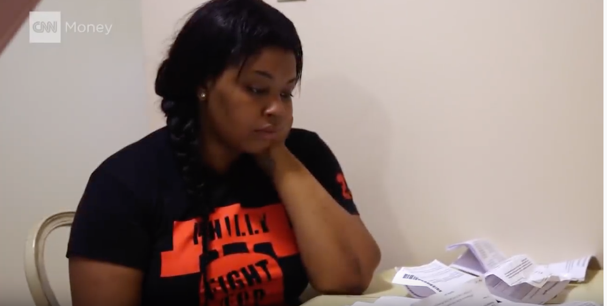
*22 yr.-old single Mother Safiyyah Cotton, grapples with how to make ends meet…even with Government aid*

Ironically, one Facebook user (Raise the Minimum Wage) addressed the same issue of cost going up as a result of the increased wages, but they also provided what could be seen as a form of a resolution to that problem. “But if minimum wage goes up, so would every product/service/fee/rent/insurance etc. would too. I think a cap on rental prices and various services etc. would help tremendously. Maybe then after that has succeeded, a slight raise in minimum wage could be achievable without staying in the same circular issues”. The significance of this idea is monumental, because it could create windows in time where consumers are able to see the benefits of an increase in minimum wage before those dividends are canceled out by inflation. Logically, it would make more sense to pay people more so that they earn more and rely on the government less. The goal is to create a form of self-sufficiency, versus revolving dependency. This poses the question, why not allow consumers to work for what would be given them anyway? Isn’t it counterproductive?
An increase or lack thereof in minimum wage has a bottoms-up impact starting at a local level, expanding nationally, and then branching out globally. Raising the federal minimum wage will also stimulate consumer spending, help businesses bottom lines, and grow the economy. A modest increase would improve worker productivity and reduce employee turnover and absenteeism. It would also boost the overall economy by generating increased consumer demand (Education & Labor Committee, 2019).

Pick A Place
For many, the increase of the federal minimum wage is only subservient to the state in which an individual resides, due to the cost of living. Although $15 per hour in Alabama may make for a more comfortable living arrangement, in New York or California, a person would be well within the poverty margin.
According to another individual from California (Facebook – Raise the Minimum Wage), “A higher minimum wage in the United States might help some states; not in California though. They raise the wage; the state creates new taxes and raises taxes to compensate. They don’t want people to gain footing or traction; they want the poor to stay poor so they can keep them on welfare programs to continue sinking the country in debt; raising the minimum wage doesn't stop greed. It hasn't helped California one bit. It still feels like I'm making $9hr...The cost of living went up with the wage hike. A one-bedroom apartment was about $500 when wage was $9hr. Now it's $900 at $12hr...and I live in one of the "lower cost" counties. This one user addresses the following…(1) based on the location or state in which he resides, an increase in minimum wage would not affect him positively, (2) the process of wage increase and then inflation, continues to create this merry-go-round effect (3) what is considered to be livable wages is primarily determined by the state you reside.
Nonetheless, one Facebook user’s response to that comment points out why the minimum wage increase is still necessary. “To compare Mississippi has one of the lowest wages in the US and has one of the highest levels of unemployment. Seems like that math is not working out”. If states like Mississippi, which offers a lower cost of living, are suffering in spite of their wages, than the location could almost be considered a mute -point. It challenges the notion that states that don’t increase their minimum wage are better off in some way, when one user points out that that is not necessarily the case.
On a global scale, the United States, once considered to be the leader in social and economic change, is now seeing more competition abroad. An Instagram post from October 3rd, (#minimumwage), highlights Britain’s embrace of a higher minimum wage, which is currently a start contrast to the U.S. As one commenter put it, “Why does the “So Call best country in the world have the lowest? In connection with livable wages not just being a U.S. “issue”, one user in the Facebook Group, National Living and Minimum Wage, commented under a post that glorified the number of low paid workers in Britain falling by 200,000 last year, “Still not good enough. Workers should be paid at least 10 pound per hour.”

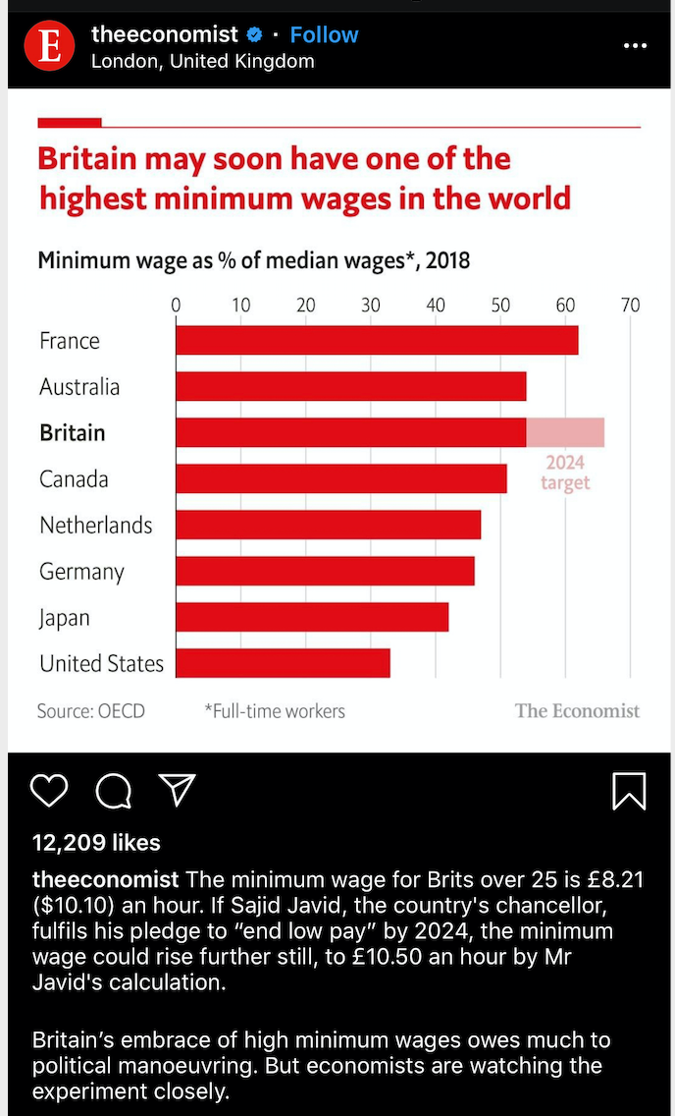
*Instagram Post from #MinimumWage, dated 10/3/19*

For Teenagers Only

There are a considerable number of people who believe that these minimum wage jobs should be for high school students or those in their novice years of their career. It drives the argument that individuals who feel as if the minimum wage is too low, should look into finding other positions in the workforce that would offer them livable wages.
For one Facebook user (Raise the Minimum Wage), he believes that the minimum wage increase would create a catastrophe for the overall goals and ambition of a high school student. “If you give Kyle a job at Burger King, one where he makes enough money to drop out of school at 16 or 17, you're going to make a whole a** society of people that settle in these jobs and never have any ambition to do more. According to this comment, creating a livable wage so early on, is a deterrent to expanding career growth later down the road.
However, another Facebook user (Raise The Minimum Wage) points out that it’s impossible for these jobs to be performed simply by college age or high school students, since someone has to work them during hours in which these individuals would be in school. “I use to manage restaurants and most of my employees were not teenagers. Teenagers can't work during most of the hour’s restaurants are open. And fast food restaurants are usually busiest at lunch when the kids are in school. Who do these people think are going to wait on them if not adults?”. This comment along with an additional one, saw the service industry as being more than just a “teeny-bopper” type of gig, due to hours of operation; some people actually like being in the service industry at any age. ““Not everyone can be a doctor, lawyer, sports star, or CEO. America will always need waiters, dishwashers, janitors, retail workers, and other laborers. So, stop looking down on others assuming they deserve to be paid slave wages. It's mean-spirited and ignorant.”
These results call into question, the potential belief that people who accept these types of jobs outside of high school age, should be confined to the minimum wage salaries that come along with them. Yet, individuals are very much aware, that someone else does have to work them, and not just teenagers.

*Service Industry workers*

Small Businesses

It’s one thing for a billion dollar businesses to consider an increase in minimum wages because they have the funds to leverage or support this; however, what about the impact to small Mom and Pop shops in your local community, if they are forced to abide by the same rules as the big boys? That question seemed to be in the ever-present minds of a lot of individuals who believe that a forced placed minimum wage would be detrimental to both small businesses and the economy alike.
Smaller businesses in some cases must decide on how or if they are able to both compensate their workers with a sustainable income, and also maintain their business. Opponents to the increase have argued that the small business sector would be hurt immensely by this practice, and it could result in reduced hours for workers, and lead to potential business closures. This leads to another potential grounded theory question, on how much responsibility should be placed on the employer to create affordable wages for the employee? Is it realistic to place a portion on the burden with the employer?
The trickle-down effect was shared by one Facebook user (Raise the Minimum Wage), who wrote…”: “Because all the little guys would go out of business. Not all businesses can afford to pay their employees that much, if they do hours get cut and so do employees. Then the business goes under and all you end up with the big corporations.” So, the focus then becomes, how do we create equality for both large and small corporations, yet still give the employee a fair chance of surviving on a manageable income? A Facebook user suggested…”“Make it possible for small businesses to pay a living wage by forcing big businesses and corporations to fairly share the tax burden.”
Meanwhile, another Facebook user (Raise the Minimum Wage) pointed out how the door for small business owners to pay employees the minimum wage is still too wide…” I think of this often. My Dad was a union organizer and always fought with his company for decent wages. I simply do not believe a business should continue if their employees are not paid a living wage. A few years ago, my son-in-law worked for a company actually owned by a friend of his. He was the only one at that time actually doing any work, and thus bringing in any income. They did not pay him for 6+ weeks because they wouldn't be able to pay their house payment nor for the private university tuition for one of their children. Meanwhile he had no income with 5 children at home. He finally was forced to find a different job.”

Discussion

The themes that emerged from this research, clearly showed that there is no one solution fits all to this problem. Individuals come to these various perspectives and opinions based on their own isolated viewpoints. Undoubtedly, the shaping of this data may be skewed by those who actually take the time to comment on social media, versus those who actually hold those same views. Commenters on social media are typically passionate enough that they desire their voice be heard through the technology channels that exist, while other opponents or supporters find no need to voice their opinions there, but more so in real life. This creates certain limitations of these studies that have to be identified.

Limitations of these studies
Despite the data capturing a 6-month open period, the information is still only a sample of a larger period of time. That sample is then further sampled, to gain an understanding of the perspectives of those that have shared feedback through social media sites; therefore, it does not fully capture a national view of every American, but merely a targeted period of time.
Changes in Perspective
Because of the timeframe limitations, it also does not possess the ability to identify if any users have a difference of opinion later on down the road. This study only stamps the point in time in which they voice their opinions but does not monitor potential changes in those perspectives overtime. Unlike game show contestants, individuals aren’t forced to give their “final answer”. They are allowed the ability to change or fluctuate in their footing of the issue, subsequently meaning that the data will likely have some form of an expiration date.

Conclusion

The purpose of this study was not only to shed light on the tug of war going on regarding a minimum wage increase, but also highlight the growing need for conservative efforts to be in place if we are to move forward as a society. What history tells us, is that the increase will likely happen, as the hourly minimum wage has increased upwardly overtime; yet, what it does not predict is the when. The aforementioned seems to be guided by the political powers that be, as expressed by Stephanie Luce on pg. 2. Consequently, it almost seems impossible that a solution will be reached, based on the divisive current standing of our nation.
Yet, there is still hope that the burden of people like Safiyyah Cotton, and others like her would prompt much needed change on Washington. The truth is, no matter the rising creation of automation, we still need physical bodies in the service industry at some level. Therefore, sitting idly by and watching individuals drown in their own financial suffering, is not an option. We are not here to penalize the occupational choices of others, but more so recognize their contribution to our daily lives, and work towards ensuring they have a place in this society as well.
Nonetheless, future research that highlights the changes of perspectives overtime, and monitors states that have already taken the initiative to raise the minimum wage would be ideal. Thereby taking a deeper dive into the metrics of median cost of living per state, governmental supplements per state in conjunction with that cost, average age of service industry workers, and what causes them to remain in an industry where they are sometimes undervalued and underpaid? These questions are just the tip of the iceberg, but in order to dissemble a “Titanic” of an issue, it requires chipping away at it, bit by bit. Undoubtedly, the process starts here.

Resources:
Arsian, K. (2011). Five Big Myths About American Small Businesses. Retrieved from: https://www.huffpost.com/entry/five-big-myths-about-amer_b_866118

Charmaz, K. (2006). Constructing Grounded Theory: A Practical Guide through Qualitative Analysis. London: Sage Publications.

CNN Business. (2015). This is Life on $7.50 an Hour. Retrieved from: https://www.youtube.com/watch?v=-SCB1t28nDU&feature=share

Education & labor Committee. (2019). Raising the Minimum Wage: Good for Workers, Businesses, and the Economy. Retrieved from: https://edlabor.house.gov/download/fact-sheet-raising-the-minimum-wage-is-good-for-workers-business-and-the-economy-&download=1

Greenes, T. Strazds, A. (2015). “Is the Minimum Wage an Effective Way to Reduce Poverty or Inequality? “ EconoMonitor, June 2, 2015.

Ihlen, O. & Fredriksson, M. (2018). Public Relations and Social Theory: Key figures, Concepts and Developments. New York, N.Y. Taylor & Francis Group.

Imbert, F. (2019). Bank of America to hike Minimum wage for all Employees to $20 per hour a year ahead of Schedule. Retrieved from: https://www.cnbc.com/2019/11/04/bank-of-america-to-hike-minimum-wage-to-20-per-hour-a-year-early.html

Inequality Org. (2019). Income Inequality in the United States. Retrieved from: https://inequality.org/facts/income-inequality/

Ingraham, C. (2018). What does a $15 Minimum wage do to the Economy? Economists are Starting to find out. Retrieved from: https://www.washingtonpost.com/news/wonk/wp/2018/01/11/what-does-a-15-minimum-wage-do-to-the-economy-economists-are-starting-to-find-out/

Kappel, M. (2012). A Detailed Overview of Federal, State, and Local Minimum Wage Law. Retrieved from: https://www.patriotsoftware.com/payroll/training/blog/what-is-minimum-wage/

Kiger, P. (2019). Minimum Wage in America: A Timeline. Retrieved from: https://www.history.com/news/minimum-wage-america-timeline

Romich, J., Hill, H. (2018). Coupling a Federal Minimum Wage Hike with Public Investments to Make Work Pay and Reduce Poverty. Retrieved from: https://www.jstor.org/stable/pdf/10.7758/rsf.2018.

Straus, A. and Corbin, J. (1990) Basics of Qualitative Research: Grounded Theory Procedures and Techniques. Newbury Pak, CA: Sage.

Wilson, M. (2012). The Negative Effects of Minimum Wage Laws. Retrieved from: https://www.cato.org/sites/cato.org/files/pubs/pdf/PA701.pdf

Zipperer, B. (2019). Gradually Raising the Minimum wage to $15 Would be good for Workers, Good for Businesses, and good for the Economy. Retrieved from: https://www.epi.org/publication/minimum-wage-testimony-feb-2019/

