Strategic Connectivity Plan

- Introduction/Purpose:
This connectivity project will analyze the growing link between social media and mental health. The significance of this research stems from the fact that younger adults are spending more time on social media, and are essentially more susceptible to mental health issues such as depression an anxiety.
- Project Description & Goals
- Project Description: Ideally this project will focus in on research presented surrounding the affects of social media on young adults, and what coping mechanisms that those utilizing these tools must take in order to protect their mental health.
Part of the reason this plan and research is so vital, stems from the fact that 1.) young adults who spend twenty or more hours on these sites per week, are more prone to suffer from self esteem or mental health issues (i.e. depression, anxiety, etc.) 2.) Since social media is not going anywhere anytime soon, users will need to establish practices that protect their mental state despite frequent engagement on social media sites such as twitter.
This strategic plan was necessary for me to explore since over recent years, there has been an increase in cosmetic surgery in young adults, which has been directly linked to social media (Cerullo, M. 2019). Consequently, if individuals are willing to alter their physical appearance as a result of social media interaction, then what can be inferred about the mental state that primarily goes unseen.
- Intended Audience: The specific target audience or niche group for this project will be adults between the ages of 18 – 36. This group was selected for a few different reasons, despite believing that the impacts of social media start at an earlier age. I selected the starting age of eighteen because at this age individuals are considered to be adults, and can make their own decisions without requiring the consent of anyone else. For those on the upper end of the age spectrum, they have likely been a part of the initial stages of social media as an adult, but have seen the transformation and progression of these sites over time. The latter group in this target audience is significant in identifying whether age and seasoning has any impact on social media’s mental bearing. This would be a question of whether experience an age trumps the weight of consistent social media use, or are the effects the same, no matter the age of the user?
- Rationale: Barr (2019) reported that more than a third of Generation Z. from a survey of 1,000 individuals stated that they were quitting social media for good, as 41 percent stated that social media platforms make them feel anxious, sad or depressed (Barr, S, 2019). Generation Z, also known by a number of other names, is the demographic cohort after the Millennials. Demographers and researchers typically use the mid-1990s to mid 2000s as starting birth years (Rosenberg, M, 2019).
Twitter is an important tool to analyze interactions of the selected demographic due its layout, and communication style. One of the initial benefactors of twitter, was that it primarily captured the thoughts of an individual without much else. Users could unite and form even smaller communities utilizing hashtags, retweets, or shares.
One example of this is the current sitting President often makes the news for tweets that he either creates, retweets or shares, that many may find opposing or simply irresponsible to send out to the public. Not to mention these tweets are sent out at odd times of the morning, when most of America is still sleeping. Therefore, the type of tweet, in conjunction with the time of the tweet, could be alarming to some, as it causes users to question mental state.
This project seeks to serve individuals in recognizing that social media (twitter) although great in establishing networks or communities, can be damaging to a person’s psyche if they don’t pay attention to some of the internal mental signs that form from frequent usage.
- Goals: One of the first steps necessary in me putting together a comprehensive strategic plan, would entail breaking down the audience who utilizes the specific hashtags #mentalhealthawareness, #mentalhealth, #socialmediaandmentalhealth, #mentalissues, etc. After my “who” is established, then the “what or how” is the next factor to develop. Understanding how users engage within those hashtags is important with potentially uncovering the “Why”. What are users able to gain from creating tweets surrounding social media and mental health? Are individual tweets more of a cry for help, or do they revolve around acknowledging that a problem does exist?
In order for me to break into these theories, it will ultimately require that I engage on twitter on a consistent basis to obtain data and research from the audience I plan to perform surveillance on.

- Community Analysis
The community analysis will consist of data obtained through online research, surveys, polling statistics, and interviews. Personal experience will also be highlighted to show a direct connection to my audience as it pertains to affects of social media on the mental psyche.
- Values: As of the first quarter of 2018, Twitter has 336 million monthly active users (MAUs). That essentially makes it the fifth most popular social network among U.S. adults, 46% of whom check the network at least once a day (Twitter Demographics, 2018)
The specified target group makes up practically half of the users on Twitter; and this statistical makeup is likely identical to some of the other social media platforms across the board. According to twitter age demographics, 40% of U.S. adults who use Twitter are aged between 18-29. That’s more than any other age group. Usage among U.S. adults drops as age increases. Pew research found that 27% of those aged 30-49, 15% of those aged 50-64, and 8% of those aged 65 and above use Twitter (down from 10% in 2016) (Twitter Demographics, 2018).
If we look at who uses twitter and the volume of the age group that utilizes it, than there may be a connection made between social media influence and frequency.
- Central Discussion: With the emergence of social media, (in the past ten years) the conversation an or dialogue surrounding mental health has intensified. Despite it originally being seen as a stigma that was cradled behind closed doors, it is now being discussed more out in the open, on several platforms.
The reshaping of the mental health stigma can be attributed to more people (both famous and non), opening up about their diagnosis, media networks shedding light on the situation and how those who suffer can seek treatment, along with communities devoting more resources to those in need.
In May of this year, WSOC-TV, dedicated a 5 part special to Mental Health, in honor of mental health awareness month. As awareness continued to grow, wellness centers were able to see a spike in mental health calls (Brown, D. 2019).
People have to be able to recognize an issue, and then be provided with resources to help them remedy the situation. Unfortunately most Twitter users, will likely not recognize that there is a problem until they find themselves on the brink of depression or worse. Nonetheless, there are initial stages that users and young adults can take to prevent them from becoming cautionary tales. This simply revolves around recognizing the signs of social media influence prior to a larger issue occurring.

- Network Map: The current go to social media platforms for the audience in question, are Facebook, Instagram, and Twitter. Based on research, seventy-three percent of the users on twitter are also on instagram (Twitter Demographics, 2019).
This is important to note, since it sheds light on the fact that influence is not relegated to a certain site or platform, but more so spread out over the course of time via several avenues. As a user, spending several hours on one social media platform for one day would likely not show any long-term effects, however, imagine if a person spent several hours a day over the course of several weeks, months, or even years on multiple platforms, then it would be harder to deny the stronghold social media has.
This network map will intertwine young adult Twitter users with those who’ve overcome mental health diagnosis (specifically depression an anxiety), those still struggling, and the resources necessary to help both identify and remedy the matter.
- Key Influencers: It is believed that those who will have the greatest impact or influence on my target audience, will be those who have first hand experience with the issue. Those in the mental health profession can help alleviate the problem through counseling and shared resources, but the initial unveiling of the root of the problem will likely come from those who look like the user and represent their demographic. Often times it’s easier to discuss a problem with people who look like and seem relatable to you.
Conversely, some of the other greatest influencers will be those who are no longer here with us. In recent years, several prominent celebrities who seemed to have it all from the naked eye, decided that life was not worth living anymore. The group ranged from actors and athletes, to chefs and designers. Their deaths highlighted the fact that mental illness was not prone to social or economic class, but a problem that was prevalent across the board regardless of those factors.
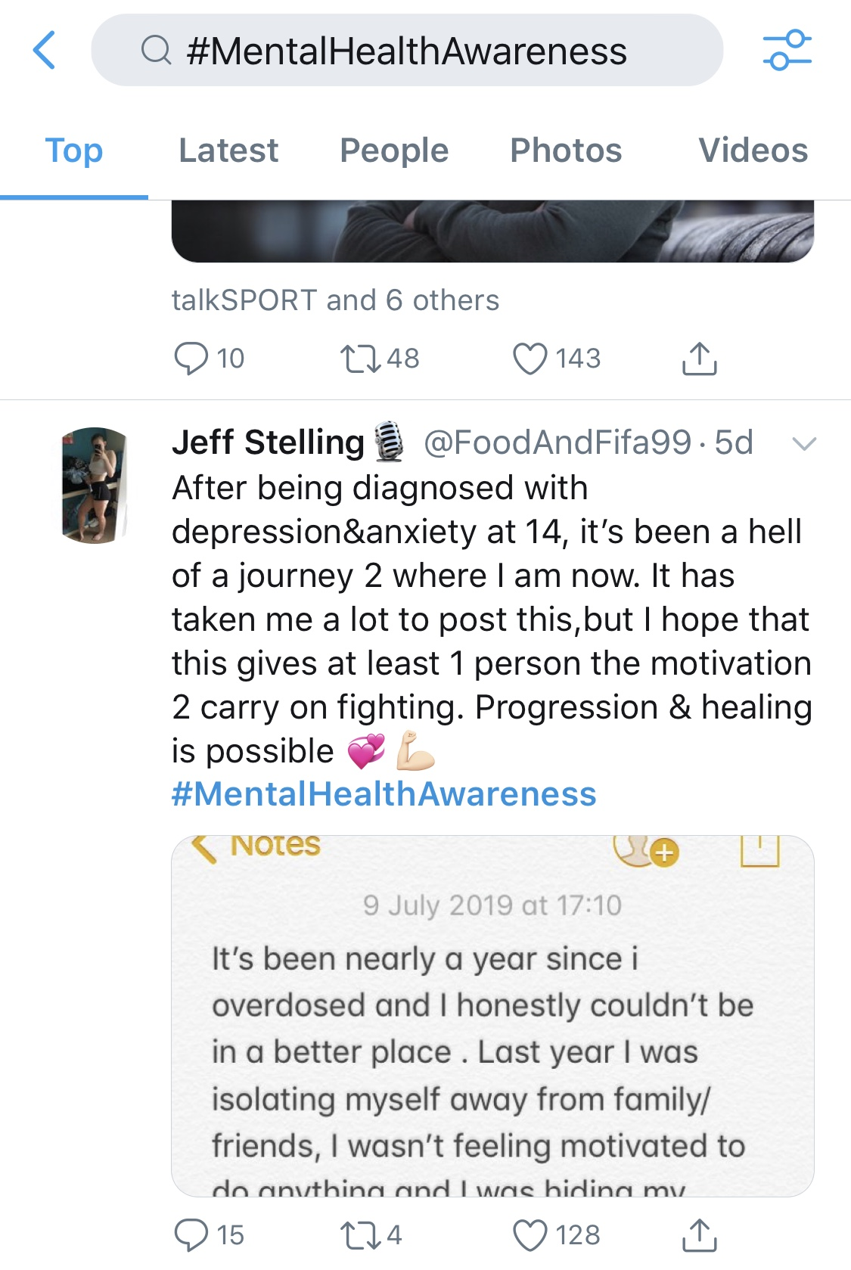
Recently former Carolina Panthers player Steve Smith, opened up about his bout with depression. When Smith first started seeking counseling, he said he was so worried about the stigma surrounding mental health that he had the counselor come to his house. But as the years of therapy have gone by, Smith said he has come to see the value of being more open (Coleman, 2019).
If those who suffer decide not to speak up, then it creates an illusion of false reality, and what you see is not always what you get. Unlike the cliché term, pictures on social media aren’t always worth a thousand words, so young adults can’t become fixated with trying to mimic what they see. Sometimes the biggest store is in the unseen narrative.

- Strengths and Challenges
I must admit, that although Twitter is not a new social media platform, it is one that I am not well connected to, or engaged with for that matter. The reason I am deterred from utilizing the site stems from me not embracing the layout, and not really having a concern with what people are thinking or doing throughout the course of the day. Nonetheless, although my lack of use on the platform makes me a novice, ironically, the upside is that it appears to be easy to use once acclimated with the functions.
Another stumbling block, stems from the fact that there seems to be limited research on the connection between social media and mental health as it ‘s a relatively new topic of discussion. Social media has been around for almost two decades, but just like real life, its impact is not often seen until further down the road. Consequently, this creates a delay in real time results, and potentially could alter the direction of a strategic plan.
The beauty of this connectivity plan is that it creates a bridge between the research and the subject so that it makes sense to the audience. Compiling data is not a hard task, but the real work comes from having to use that data to tell a relatable story.
It is undeniable that social media is heavily engrained in the fabric of our lives, but we seldom see the impact of its frequent use until it is too late. My artistry comes into connecting the dots so that people understand the who, what, where, and why.
I plan to use twitter as a means of understanding how content influences audience response, and then measuring whether or not the tool is instrumental in mitigating or diminishing social media stigma on mental health.

- Theoretical Framework
This strategic connectivity plan will look at Goffman’s Impression analysis, to dissect the correlation between social media and mental health. When researching interpersonal relationships with internal and external publics, our understanding of social interaction is vital (Ihlen & Fredriksson, 2018, p. 252).
Goffman’s sociological work is centered around theories of social interaction derived from his empirical work in different settings. He analyses the relationship between interpersonal meanings and social structure, paying attention to both the symbolic value of what is said and done and the more abstract forms of social life. A comprehension of Goffman’s ideas can contribute to deepen our understanding of how the social world is experienced and reproduced (p. 253).
Impression management signifies that people use communication deliberately and strategically to create desired impressions of themselves. In interaction with others, a person uses communication to manage other people’s impression of himself or herself. The audience checks upon the validity of what is said in words and what is expressed by other means(p. 255).
In interpersonal communication, interactants are co-constructing the definition of the situation. However passive the role of an audience or a listener may seem to be, every person will define the situation by virtue of the response to the individual, and the communicated impression (p. 255).
Goffman’s theoretical framework on impression management, framing, footing, and facing, layout the foundation for how social media is an influencer on young adult users. Through integral methods, this theory establishes how twitter and other social media sites frame our thoughts through constant use, change our footing through both verbal and non-verbal signals, an alter our “public self image” as a result of face.

- Content Curating and Message Experimentation
This portion of the project will look at how content is curated and then distributed across a communication platform, in order to track and analyze meaningful patterns of communication. Twitter was utilized to share messages and content surrounding social media influence, in hopes of building connectivity within my community.
- Communication Tactics: Over the course of the past six weeks, Twitter was set to be the primary tool utilized to capture statistical research, pose questions, and share valuable information, as it pertains to the connection between social media and mental health. Each week, twitter users were prompted to assess their social media mannerisms, and then analyze how those habits may have an impact on their mental state. Users were also provided with methods on how to handle the effects of social media, in the event they found themselves suffering from some of its pitfalls.
Unfortunately, due to the lack of twitter followers and time to establish a steady following, it became extremely difficult to build a connectivity plan through this platform. Based on the way twitter operates, the more of a following that a user has, the higher the probability of engagement from followers. Twitter also limits full dialogue or engagement (via character limitations), an is primarily used for quick interactions or updates, versus fully thought out discussions. Not to mention, due to all of my followers being peers, the only manner to build connections on my topic was through hashtags such as #SocialMediaAndMentalHealth, and #MentalHealthMatters. These hashtags often provided content and research data that could be shared, but did not further the conversation or discussion surrounding the issue.
Therefore, I determined that the best way to capture my audience, was to go directly to them. Since I already had an established friends list of over 3500 individuals on Facebook, I used this platform to gain participants for a survey that asked specific questions pertaining to my theory. This method appeared to be most effective as it allowed for direct engagement with participants, and polling data could be reviewed and analyzed with less restraint.
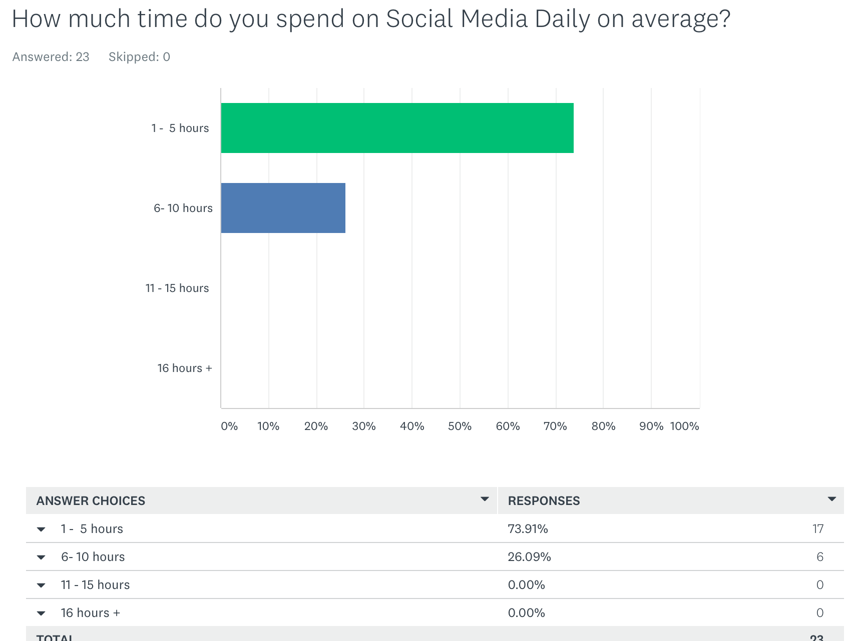
- Analytics: Polling through Survey Monkey was highly effective, as data from questions, could then be used to gauge or test the theory at hand. First and foremost, individuals were encouraged to survey the amount of time they spend on social media. This was imperative to determine early on, as a partial premise of my connectivity plan is that the more time an individual spends on social media, than the more prone they become to mental health concerns such as depression an anxiety. Conversely, additional research also indicates that time spent on social media alone is not a direct indicator that a person’s mental state would suffer. A new study published in the Lancet Child & Adolescent Health, suggests the issue is even more nuanced. Social media is associated with mental health issues, the research says- but only under certain circumstances, and only for certain people (Ducharme, 2019). Factors such as age, gender, primary purpose for using social media, and a person’s spiritual compass, all play a role in determining the level of impact that social media’s usage will have on an individual.
Twenty-three individuals completed the survey, and each of them shared their personal feelings on how social media was both utilized by them, and impacted their mental state albeit positively or negatively. What I found, is that an already established network through Facebook, allowed people to have a greater comfort level when it came to sharing information, because there was a personal connection there that could not essentially be established the same way as through 6 weeks on Twitter.
Based on responses, it supported data that women were more likely to be impacted by social media than men. This could be due to the fact that women seem to engage more on social media than men, and are typically more emotional beings. Social media platforms may encourage people to compare themselves to others. Studies found the tendency to compare oneself to others on social media – whether you see yourself in a more positive or more negative life – is a significant risk factor for depression and anxiety. In addition, people with depression were more likely to rate themselves as being inferior to others on social media compared to those without depression (Complex Links Between Social Media & Mental Health, 2019).
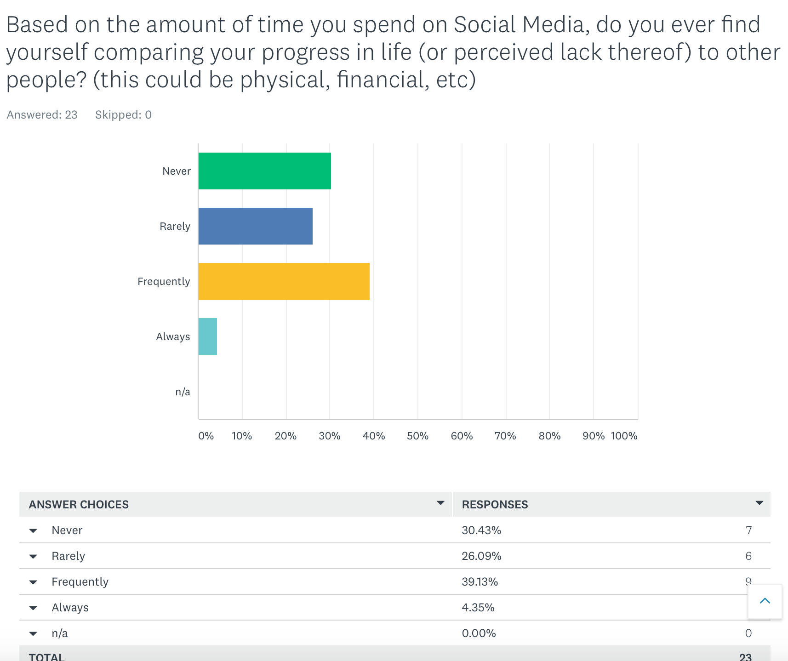

- Learning: This project highlighted the fact that established networks matter when attempting to build community engagement. Users have to feel comfortable with both “what” is being asked, and “who” is asking it. Individuals who participated in the survey seemed to be more transparent with information that they had likely not shared with others publicly, as a result of having some form of connection to me through Facebook. In order for data to be deemed reliable, it has to first be truthful.
Goffman’s concepts of impression management, framing, footing, and face could serve as a theoretical foundation to the empirical study of social interaction in organizational settings. This framework focuses on social interaction and provides a description of how language is situated in particular circumstances of social life, and how it reflects, and adds meaning and structure in those circumstances (Ihlen & Fredriksson, 2018, p. 253). Through polling, research, and interviews with those in the psychology field, Goffman’s impression analysis sheds light on how social media’s impression can frame an individual’s mental state.
- Communication Strategies
The below suggested strategies highlight areas in which Social Media users can work to decrease time spent on social media by engaging in more face-to-face interactions, and ultimately creating more positive networks to boost their mental morale.
- Recommendation: One effective communication strategy will look at how to enhance users ability to self identify or recognize the impacts of social media on their mental health in a shorter span of time, and then engage in the necessary networks to combat those issues. Impression management signifies that people use communication deliberately and strategically to create desired impressions of themselves (Ihlen & Fredriksson, 2018, p. 255).
The Social Media platform itself is not problematic, as it creates a mechanism for users to engage with friends and family on a consistent basis. For many people, social media provides social support and connectedness that they would otherwise miss. Essentially, social media allows users to connect with people they may not otherwise come into contact with and express emotions and parts of their identity that may be more difficult to communicate in face-to-face interactions (The Complex Links between Social Media & Mental Health, 2019).
However, when the amount of time spent on sites such as Facebook, Twitter, Instagram, etc., is coupled with an individual’s internal feelings of inadequacy based on their current state in life (i.e. physical, mental, financial, social, etc.), than social media can become a catalyst or trigger for depression and anxiety.
To combat this, Social media users are strongly encouraged to limit the daily/weekly amount of time they spend on social media. This can be done manually by going into their phone settings and then restricting the amount of time for social media to no more than 1-3 hours per day. One psychology professor at San Diego State University discovered teens who spend 5 or more hours a day online were 71% more likely to have a least one risk factor for suicide, compared to teens who spent only 1 hour a day online. The risk increases with only two or more hours spent online. Again, this doesn’t prove that spending time online causes suicide, but the link between time spent online and other factors linked to suicide is important to study (Mir & Novas, 2019)
The next recommendation would require users to become more intentional about the groups they partake in on social sites. If individuals are a part of more uplifting or positive networks that embrace things they are passionate about such as art, yoga, etc., than they are more likely to sustain a healthy appetite when it comes to social media. This also includes support groups for those who are challenged by current mental health issues they are facing. Social Media can become a safe haven, instead of a place of isolation if individuals can find support in common issues.
- Support for Recommendation: Framing according to Goff man, is a way to explain the background parties need to interpret the ongoing conversation. We tend to perceive events in terms of primary frameworks, and the type of framework we employ provides a way of describing the event to which it is applied. Expectations facilitate our comprehension and interpretation of objects and events, while also influencing our perceptions. “Taken all together, the primary frameworks of a particular social group constitute a central element of its culture” (Ihlen & Fredriksson, 2018, p. 256).
It is necessary to build connectivity models on how to deal with social media, as the platform will not expire anytime in the soon to near future. Proper framing, allows the individual to see social media platforms as more than just entertainment tools, but establish networks that can become beneficial to them socially, financially, physically, etc.
Additionally, footing concerns a participant’s stance or posture in interaction; in Goffman’s own words: “Participant’s alignment, or set, or stance, or posture, or projected self is somehow at issue”(p. 257). Although framing will alter how individuals see social media sites, footing is necessary to define interaction and tone. Those who limit their interaction on social media through time spent and networks, can alter their overall stance both on and offline.
Ultimately, face is “the public self-image” that individuals want to claim for themselves, and a tool to describe social relations. “Face is something that is emotionally invested, and can be lost, maintained, or enhanced, and must be constantly attended to interaction”. Brown and Levinson treat the aspects of face as basic wants, and see two components of the concept; negative face – the want of every “competent adult member” that actions be unimpeded by others, and positive face – the want of every member that wants be desirable to at least some others (p. 258).
Recommendations of intentional engagement, establishing time restraints, and focusing solely on positive interactions via social media, are all mechanisms for Goffman’s Impression Analysis, and serve as ways to combat some of the increased mental pressures seen as a result of these sites.

- Communication Tactic: In order for users to see the benefits of controlled social media engagement, the message should stem from the top and not the bottom. Founders of these Social Media platforms should ultimately create avenues that curtail focus on superficial or shallow rewards, and push for curation of more authentic relationships and network building on these sites. Recently Instagram changed some of its algorithms, so users could focus more actual interaction than concentrating on how many “likes” they received. Many users will delete photos that do not get “enough” likes. Numerous studies have been conducted on the culture surrounding social media and the unhealthy obsession with “likes” and comparison to others online. A recent report from UK’s Royal Society for Public Health (RSPH) and they Young Health Movement looked at the impact of different social media platforms on mental health. While there were some positives about accessing health information, the opportunity for self-expression and a feeling of community, the negative factors were heavy. Things like anxiety, depression, loneliness, sleep quality and negative impact on body image were all reported (Martin, 2019).
- Timeline for Implementation: Immediate changes with regard to these platforms would likely produce immediate results on an individual basis, but ultimately the impact should be seen across the board.
- Required Resources: Phone to alter settings, social media accounts, interest and support groups.
- Goals/Metrics: Users should be able to self assess if their current engagement is impacting their mental health, and then be proactive in taking the necessary steps to remedy the situation through the aforementioned methods described. The impact of this project should start on an individual level, but the effects should be seen in interactions via organizations and communities.

- Conclusion
Social media has given us the ability to have a diary at our very fingertips. We can post our feelings, albeit good or bad, and get immediate responses from those in our social circles. Unfortunately, if we do not have an established network of positive reinforcement, than time spent on social media can become a troubling place.
This connectivity plan sought to analyze the current issues surrounding the correlation between social media and mental health, and then provides solutions on how to combat those issues.
Ideally, this project requires intentional action on behalf of the users of social media platforms, and the creators of them alike. When developers see something beyond a simple project or app that connects people, and identify users being a sister, brother, parent, or friend, then they’ll become more intentional about the algorithms that feed into mental health on these sites. Although, it’s not their responsibility to control how individuals use it, they should still be cognitive of the impacts of its frequent use.

Resources:

Cerullo, M. (2019) More Millennials are Getting Plastic Surgery, Driven by Social
Media and Jobs. Retrieved from:
https://www.cbsnews.com/news/millennials-plastic-surgery-surge-due-to- social-media-and-jobs/

Coleman, M. (2019). Steve Smith on his battle with depression: “I Started to realize
that I’m not Broken’. Retrieved from:
https://amp.charlotteobserver.com/sports/nfl/article230653274.html

Ducharme, J. (2019). Social Media Hurts Girls More Than Boys. Retrieved from:
https://time.com/5650266/social-media-girls-mental-health/

Ihlen, O., Fredriksson, M. (2018). Public Relations and Social Theory. New York,
NY. Routledge

Mir, E., Novas, C. (2019). “Social Media and Adolescent’s and Young Adults Mental Health. Retrieved from: http://www.center4research.org/social-media- affects-mental-health/

Orlando, J. (2019). Here’s Why Instagram Getting Rid of Likes Could be a Big Deal for Our Mental Health. Retrieved from:
https://www.sciencealert.com/instagram-has-a-trial-to-hide-the-number-of-likes-in-the-hope-that-it-saves-self-esteem

Rosenberg, M. (2019). “Generational Names in the United States”. Retrieved from: https://www.thoughtco.com/names-of-generations-1435472

“The Complex Links Between Social Media and Mental Health”. (2019). Retrieved from: https://www.psychologytoday.com/us/blog/evidence-based-living/201903/the-complex-links-between-social-media-and-mental-health

“Top Twitter Demographics that Matter to Social Media Marketers”. ( 2018).
Retrieved from: https://blog.hootsuite.com/twitter-demographics/amp/

